MINI PROJECT

**(2021-22)**

**“GUIDE FOR FARE AND CONVEYANCE”**

Project Report



**Institute of Engineering & Technology**

**Submitted By -**

###### Nazia Farheen (191500485)

###### Samradhi Khare (1915000708)

###### Shubhanshi Chaudhary (191500804)

**Under the Supervision Of**

**Md. Amir Khan**

**Technical Trainer**

**Department of Computer Engineering & Applications**

Department of Computer Engineering and Applications GLA University, 17 km. Stone NH#2, Mathura-Delhi Road, Chaumuha, Mathura – 281406 U.P (India)

## Declaration

I/we hereby declare that the work which is being presented in the Bachelor of technology. Project **“Fare Guide For City Ride”**, in partial fulfillment of the requirements for the award of the ***Bachelor of Technology*** in Computer Science and Engineering and submitted to the Department of Computer Engineering and Applications of GLA University, Mathura, is an authentic record of my/our own work carried under the supervision of **Md. Amir Khan, Technical Trainer, Dept. of CEA, GLA University.**

The contents of this project report, in full or in parts, have not been submitted to any other Institute or University for the award of any degree.

**Sign**: *NaziaFarheen* **Sign**: *SamradhiKhare*

**Name of Candidate**: Nazia Farheen **Name of Candidate**: Samradhi Khare

**University Roll No**.:191500485 **University Roll No**.:191500708

**Sign:** *ShubhanshiChaudhary*

**Name of Candidate**: Shubhanshi Chaudhary

**University Roll No:** 191500804

Department of Computer Engineering and Applications GLA University, 17 km. Stone NH#2, Mathura-Delhi Road, Chaumuha, Mathura – 281406 U.P (India)

**ACKNOWLEDGEMENT**

Presenting the ascribed project paper report in this very simple and official form, we would like to place my deep gratitude to GLA University for providing us the instructor Md. Amir Khan, our technical trainer and supervisor.

He has been helping us since Day 1 in this project. He provided us with the roadmap, the basic guidelines explaining on how to work on the project. He has been conducting regular meeting to check the progress of the project and providing us with the resources related to the project. Without his help, we wouldn’t have been able to complete this project.

And at last but not the least we would like to thank our dear parents for helping us to grab this opportunity to get trained and also my colleagues who helped me find resources during the training.

###### Thanking You

**Sign**: *NaziaFarheen* **Sign**: *SamradhiKhare*

**Name of Candidate**: Nazia Farheen **Name of Candidate**: Samradhi Khare

**University Roll No**.:191500485 **University Roll No**.:191500708

**Sign:** *ShubhanshiChaudhary*

**Name of Candidate**: Shubhanshi Chaudhary

**University Roll No:** 191500804

**ABSTRACT**

India, a developing country, faces very phases every day in many aspects.

Our government is running various schemes at a country as well as country level. From education to job, most of the population is moving from their residential place to a very new place most probably unknown to them. In a new place, the first problem is to select a resident then next is a conveyance. In a new city, we have no idea about the fare of conveyance and also about the route by which we can easily reach to our destination with the help of public transport. Generally, people have no idea about the conveyance as well as their fare details.

So, we are developing a software which tells us about the best route and conveyance with proper fare details from your selected source to the destination point. In this project, we are using Data Science, Machine Learning, and NLP tech and operate it with firebase for cloud data.

Now, this is a mini project so here we are working on a small data set for normal or we can say those non-disabled people. It will help people to know the best route to reach their destination at the proper fare. It will also help to praise the use of public transport that helps in our governmental progress. In the future, we add more functions for people with disabilities and Artificial Intelligence Technology.

**CONTENTS**

Cover Page i

Declaration ii

Certificate iii

Training Certificate… iv

Acknowledgement vii

Abstract viii

Content ix

List Of figures xi

List Of tables xii

Chapter 1Introduction 1

* + 1.1 Context… 1
  + 1.2 Motivation 1
  + 1.3 Objective 2
  + 1.4 Existing System 2
  + 1.4 Sources 3

Chapter 2 Software Requirement Analysis 4

* + 2.1 Impact Of Books On Daily Life 4
  + 2.2 Problem Statement… 5
  + 2.3 Hardware and Software Requirements 6
  + 2.4 Modules and Functionalities 6
  + 2.5 Bookopedia on Android Application……………,,,,,, 7

Chapter 3 Software Design… 8

* + 3.1 Use Case Diagram 8
  + 3.2 Data Flow Diagram 11
  + 3.3 Sequence Diagram 12

Chapter 4 Technology Used… 13

* + 4.1 Android… 13
  + 4.2 Version of Android 14
  + 4.3 Tools and Languages 15
  + 4.4 Basic Terminology 16

Chapter 5 Implementation and User Interface 19

* + 5.1 Implementation of Bookopedia 19
  + 5.2 User Interface 23

Chapter 6 Testing 33

* + 6.1 Installation Testing… 33
  + 6.2 Unit Testing… 34
  + 6.3 User Testing 37
  + 6.4 Performance Testing 38
  + 6.5 Compatibility Testing 39

Chapter 7 Conclusion 40

References *41*

**LIST OF FIGURES**

###### Existing System 2

###### Use Case Diagram 9

###### Data Flow Diagram 11

###### Sequence Diagram 12

###### Android Kit-Kat… 14

###### Flow Chart for User 21

###### Splash Screen 23

###### Register Page 23

###### Login Page 24

###### Forget Password… 24

###### Navigation Drawer 25

###### Dashboard Fragment… 26

###### Profile Page 27

###### Favourite Page 28

###### Sign-out Page 28

###### About App Page 29

###### FAQ Page 29

###### Search Book Page 30

###### Description Page 30

###### Book List 31

###### Book added to Favourite… 31

###### Favourites 32

###### Book removed from Favourite 32

# LIST OF TABLES

###### Version of Android… 14

###### Unit testing of Bookopedia 34

###### **CHAPTER – 1**

###### **INTRODUCTION**

###### **Context**

This Software “Guide for Fare and Conveyance” has been submitted in partial fulfilment of the requirements for the award of the degree of Bachelor of Technology in Computer Science and Engineering at GLA University, Mathura supervised by Md. Amir Khan. This project has been completed approximately three months and has been executed in modules, meetings have been organized to check the progress of the work and for instructions and guidelines.

* 1. **Problem Statement**

In recent last year number of transportation increasing. In India, in need of education to job, most people shift from their home town to a new place that is completely unknown to them. They have no idea how to go to a particular place especially by using local area conveyance with a fare as per decided by the government of India. They google for everything and spend their lots of time on a search for how to go, where to go, where we get conveyance, what is the proper time to get conveyance, what was the last time to get a conveyance for a particular destination. Yes, there is an option of booking by OLA, UBER, etc. but not everyone can afford it.

**1.3 Motivation**

In this project, we all are students and we leave are home town or city for our college studies, so we can understand the difficulty of transportation in a new city. We need something out of railway station, bus stop and airport that tells us about all the possible local area routes for our destination with proper conveyance at a certain fare for using public transport.

* 1. **Objective**

The main objective of this project is to build a software that will contain the information about all possible routes with proper conveyance with appropriate fare as per decided by the government of India. It will answer all your queries about how to reach your destination by using public transport and also compare the price of booking transport so you can take a perfect decision.

**1.4 Existing System**

For the last decade number of transportation has increased as per the increasing number of universities and companies. From Student to working person everyone moves from their home to working place without knowing anything about that city. Currently, we are using GOOGLE MAP for finding routes. But there are the following drawbacks of the existing systems that can be resolved by our project are–

* Not every suggested route has local area conveyance
* Fare of suggested booking conveyance is not affordable every time.
* Hesitation in asking local citizens for public transport
* Non-Friendly nature of local citizens
* Misguidance about conveyance
* Unspecified availability time of local area conveyance like bus etc.

**CHAPTER – 2**

SOFTWARE REQUIREMENT ANALYSIS

In Guide for fare and conveyance project we are basically working on Machine Learning, Data Science and NLP (Natural Language Processing).

# Software Specification

* Technology Implemented : Data Science, Machine Learning, NLP
* Language Used : Python
* Database : Firewall
* User Interface Design : Mic and Speaker based Computer System
* Web Browser : Chrome, Firefox

# Hardware Requirements

* + - Processor : Intel i3/i5/i7
    - Operating System : Windows 7/8/10
    - RAM : 8+ GB
    - Hardware Devices : Computer System, Mobile Phone
    - Hard disk : 64 GB
    - Display : Monitor, Speaker

Here, we describe all the technology and their use as follows –

**Machine Learning: -** Machine learning is the study of computer algorithms that can improve automatically through experience and by the use of data.In our project, we are using machine learningto input all the data about routes, conveyance available on that route with pre-decided fare as per by our government and to predict best outcomes.

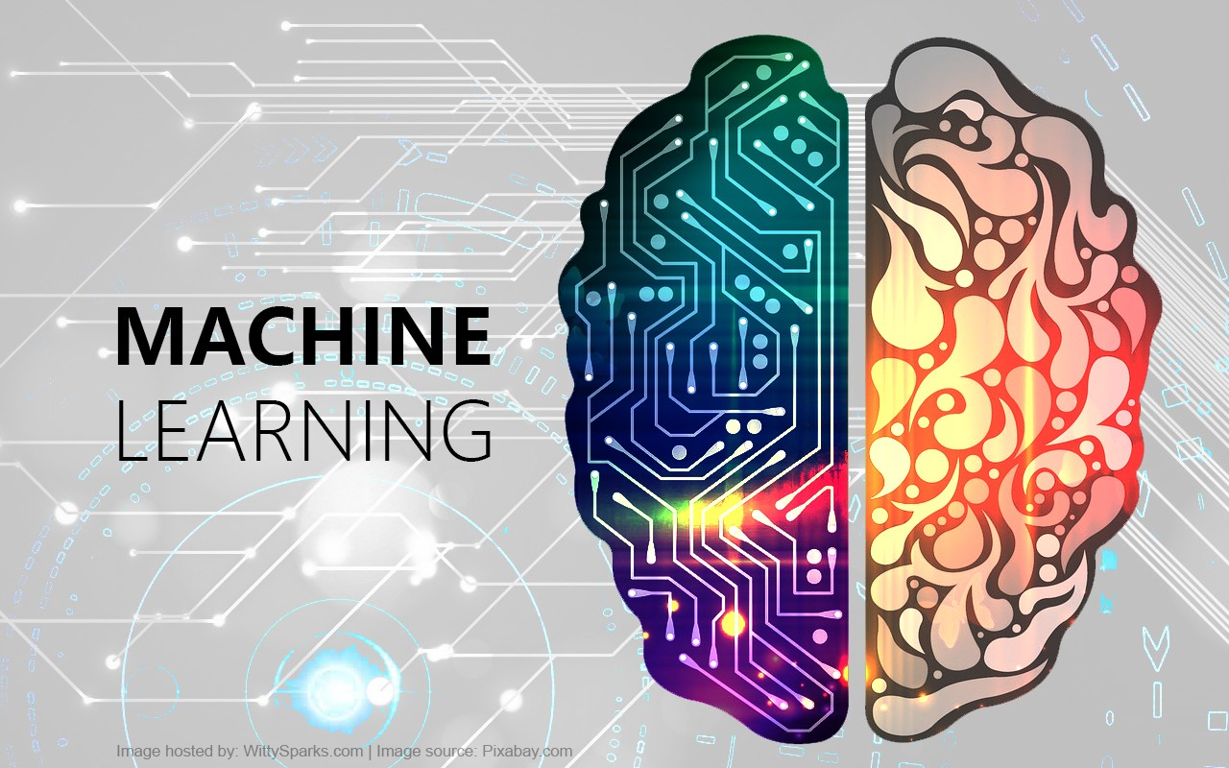

**Data Science: -** Data science is an interdisciplinary field that uses scientific methods, processes, algorithms and systems to extract knowledge and insights from noisy, structured and unstructured data, and apply knowledge and actionable insights from data across a broad range of application domains. So, we use Data Science technology to analyze our data to predict more accurate and best result.

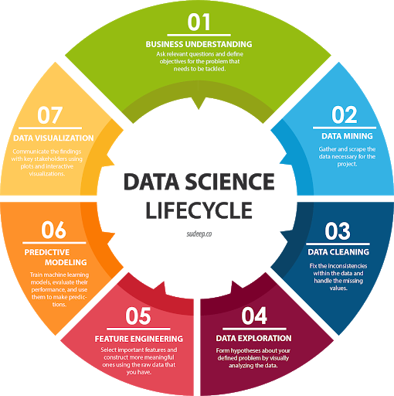

**NLP: -** Natural language processing strives to build machines that understand and respond to text or voice data—and respond with text or speech of their own—in much the same way humans do. As we are working on a software that directly interact with humans, need of NLP is must to remove ambiguities.

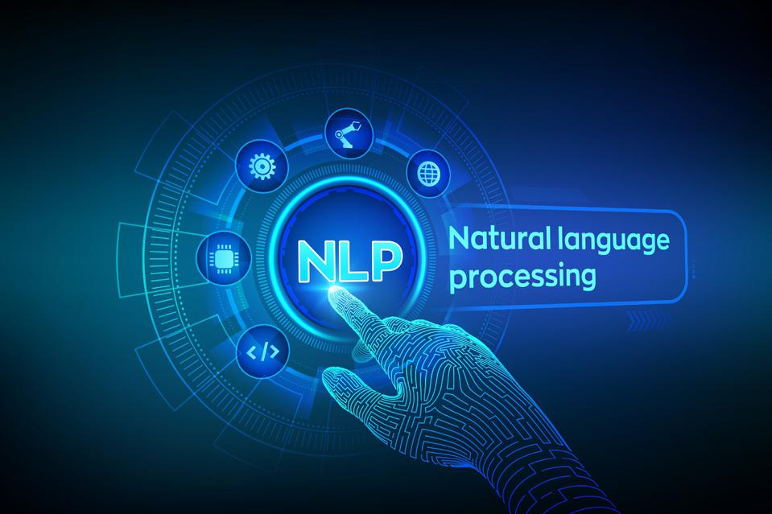

**Language Used: -**

We are using python language for our project. Python is commonly used for **developing software, task automation, data analysis, and data visualization**. Since it's relatively easy to learn, Python has been adopted by many non-programmers such as accountants and scientists, for a variety of everyday tasks, like organizing finances.

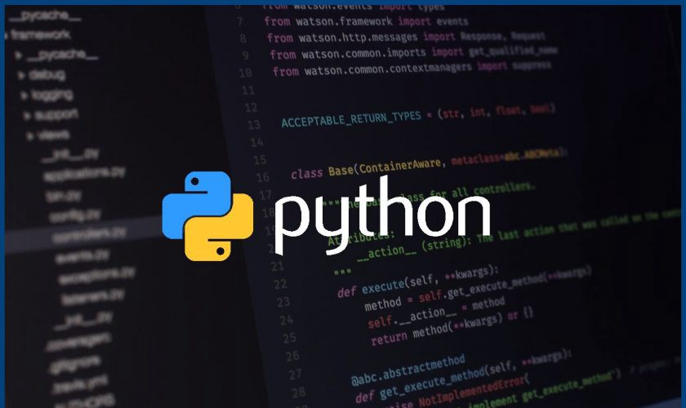

**Data Base: -**

We are using Firebase. It is a platform developed by Google for creating mobile and web applications. It was originally an independent company founded in 2011. In 2014, Google acquired the platform and it is now their flagship offering for app development.

Here, we store our data online on a server as cloud data.



**User Interface: -**

For user interface we are using mic to read the inputs and speakers to give the output in a voice node form.

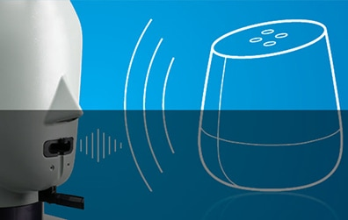

**Web Browser: -**

We are using Chrome and Firefox for web browsing





**CHAPTER – 3**

**IMPLEMENTATION AND USER INTERFACE**

We are going to implement this project on jupyter platform. On jupyter we make our software.

Our software interact with users in the form of voice or screen output such as atm machine. It takes input by recording audio or selecting multiple options on screen, then suggest best output on screen or as voice note.